Flower evolution. Genes of flower development

(Diversity of monocot flowers. Arabidopsis mutants of floral homeotic genes)

Health and safety:
Risk: Sharps (glass slides and scalpel).
Control: Use caution when handling the scalpel, which is extremely sharp. Hold it correctly and avoid fast movements while having it in your hand.

Learning outcomes

By the end you should:
- understand how evolutionary processes have modified the development of flowers, making specialised reproductive strategies possible.
- grasp the role of single genes in developmental, and potentially in evolutionary processes, using floral morphology as a case study
- gain experience in genetic insight: the ability to uncover biological processes from the study of mutants.

1. Archetype and derived monocot flowers: what developmental changes have resulted in specialised reproductive strategies?

Classical botanists long recognised that behind very different-looking plants there are strong morphological commonalities. This is particularly the case among flowering plants, when examining the flowers themselves: plants of totally different appearance and lifestyles can have essentially identical flowers. One large group of flowering plants is that of the monocotyledons, or monocots. In this practical you will examine two highly specialised monocot flowers, one for very restrictive insect pollination (the orchid Cymbidium) and one for totally unspecific wind pollination (the grass Avena). As a ‘base line’ to compare with, you will also have a lily flower. While not really “primitive”, lilies possess something similar to what we believe to be the basic floral structure of ancestral monocots.

Examine one example of each type of flower (lily, orchid, grass). Best to start with the “ancestral”. Take as much material as necessary, but remember to leave enough for your colleagues. Observe it as a whole and after dissecting it as appropriate. Grass flowers (florets) are very short-lived. If the floret has a hard “grain” (a fruit fused to the single seed it contains), it will be too old to observe many floral structures. Young florets will enclose an ovary with a milky content (endosperm, initially liquid, accompanying the young embryo). Use a stereomicroscope as necessary. Cut, open, dissect.
If by the end you have not destroyed it, you have not examined it properly!
Use these descriptions to assist in your dissections and identification of organs:

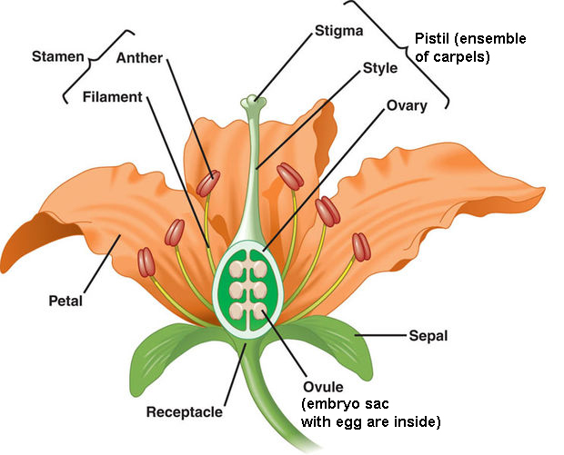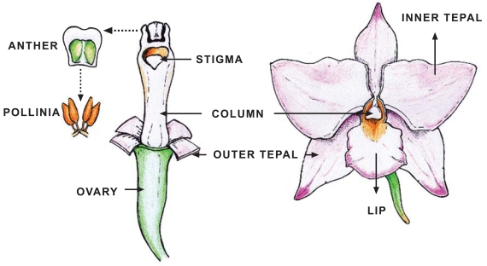
Lily (Lillium)
(http://www.instructables.com/id/How-To-Germinate-Lilies/)
Orchid (Cymbidium)
(Aceto and Gaudio 2011, Current Genomics 12, 342-356)
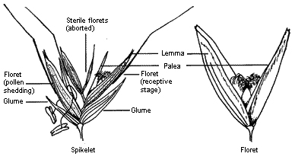
Grass (Avena)
(http://www.fog.org.au/grasses_of_nsw/grasses_of_nsw.htm)
In each case it will help you if you capture your observations in the form of one or more diagrams, which answer the questions below. Taking pictures would be an alternative, if you label and annotate them:
- Are there ‘conspicuous’ sepals and petals present? Are they distinct? How are they arranged? In the orchid identify the labellum. In the grass identify the glumes (which surround several flowers and are therefore neither sepals nor petals) and the lemma and palea.
- Are the flowers perfect (bisexual) or unisexual?
- How many stamens are there, what is their individual morphology and what is their arrangement?
- For the orchid, identify as many as possible of the following specific constituents: column, anther cup, pollinia. Indicate them in your scheme or picture. Remember that in the orchid a vast amount of organ fusion has resulted in ‘typical’ stamens and carpels becoming unrecognisable.
- Where is the ovary? Cut the ovary transversally: How many carpels (ovary-forming leaves) is it formed by? You may see that each carpel forms one independent cavity, or that they all together form one. Often (in the lily and grass) the number of lobes of the stigma equals the number of carpels. In the orchid you will need to cut transversally the pedicel below the flower receptacle, where the petals are attached. You will see the carpels and the pedicel tissue surrounding them.
- Where is the stigma, and what does it look like? Where are the ovules (which when fertilised will become the seeds), and what is their size? Look for ovules also in the orchid, but don’t be surprised is you can’t identify them, they are highly underdeveloped and barely recognisable.
- What is the morphology of the pollen? Are all three pollen grain types of the same size or surface texture?. For this you will need to mount a small amount of pollen of each kind in the same microscope slide (to compare easily), without mixing them.

Try and write, as a summary, a floral formula for each, in the form:

Kn Cn An Gn

Where K is sepals (calyx), C is petals (corolla), A is stamens (androecium), G is carpels (gynecium) and n is the number of parts in each case. K and C may be replaced by T (tepals) if no differentiation exists. The parts wich are fused should be put in brackets. The gynecium should be G if superior (other parts emerge below) or Ğ if inferior.

It would help you if you finally drew one more but simplified diagram, with all three types of flower, indicating, with arrows linking the homologous structures, the types of transformation which have taken place to derive from a lily-like flower (a) one like that of the orchid or (b) one like that of the grass. You can, of course, do this also with annotated pictures.

What types of pollination mechanisms do you anticipate for each?
2. Floral homeotic genes in Arabidopsis: how is the development of floral organs determined?

The transformations seen above are, ultimately, nothing but developmental changes having taken place through evolution, and having resulted in adaptive fitness (for specific pollination purposes). Evolution “works” on genes. In this second part we will examine some of the most basic genes which play a role in the development of flower organs. Four mutants (w, x, y and z) of the model plant Arabidopsis are provided. Three of these are defective in the development of the flowers, in such a way that one type of organ is transformed into a different type. Such changes are called homeotic transformations. The fourth one is globally defective in the differentiation of individual flowers.
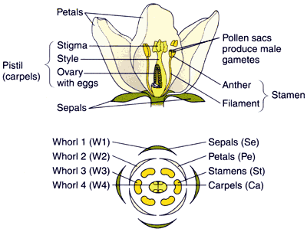
Examine the wild type flower carefully, under the stereomicroscope and dissecting it (see figure). They are typical of a crucifer (cabbage, mustard, oil seed rape, etc). Confirm the number and position of sepals and petals (same number), stamens (seem the same as the petals, but note there are two extra shorter ones) and carpels (cut transversally a developing fruit, and you should see the number of cavities, therefore the number of carpels forming the ovary/fruit).
http://scienceblogs.com/pharyngula/2006/11/mads_boxes_flower_development.php
Observe then the mutants with great care to identify the differences.
Use well-developed, mature flowers
Remember: It is impossible to make appropriate observations without cutting material open, dissecting, and using the stereomicroscope.
Look at the type, number and position of different organs. Examine carefully under the stereomicroscope: do not trust first impressions. For example, flowers of one mutant show green organs which may be taken as sepals, but which carry at the top what appears to be stigma, and in older flowers may also have exposed ovules. Such an organ is obviously not a sepal, but a carpel!
Some changes may be even more apparently extreme: a floral organ may sometimes develop normally, yet other times not develop as an organ at all, but as an entire flower, leading to a flower presenting secondary flowers! Be alert to such a possibility.

- Observe, for each mutant flower, what features are different from the wild type. Do not bother with the vegetative morphology of the plants, the differences are in the flowers!
- In mutant w, a gene involved in the transition from inflorescence meristems into individual flowers is faulty. What happens as a consequence?
- For the remaining three genes, try to assign a role for each in normal floral development. To do this, it would be helpful to write a matrix of the different floral organs, indicating which is normal or aberrant in each mutant, as follows:

 | 1st whorl (normally sepals - only) | 2nd whorl (normally petals) | 3rd whorl (normally stamens) | 4th whorl (normally carpels)
Wild type | Normal | Normal | Normal | Normal
mutant x
mutant y
mutant z

Now work out, for example, what gene X, which is faulty in mutant x, does in the wild type. It would do whatever happens in the wild type but is missing in the mutant! Then work out whether individual “whorls”, or circles of one kind of organs, develop as a result of the action of a particular gene or gene combination.

Further sources
- Hillis DM et al. (2020) Life, the Science of Biology. Macmillan. Chapter 27.
- Evert RF and Eichorn SE (2013) Raven Biology of Plants. Freeman, NY. Pages 482-492 and 604-609.
- Smith A et al. (2009) Plant Biology, Garland, Abingdon. Pages Pages 350-360*.
Also of use, and with links to Arabidopsis as a model organism:
- http://labs.biology.ucsd.edu/yanofsky/home.html

