Report. SEB Anim. Biol. ECR symposium

On the southern coast of Finland, located somewhat remotely in the Ekenäs Archipelago National Park among small islands and forests, lies Tvärminne Zoological Station, a biological station of the University of Helsinki, the venue for the 2022 SEB Early Career Researcher symposium in Animal Biology. For four days, 43 PhD students and postdocs from all over the world, as well as four keynote speakers, were gathered there to present their research, make new friends and collaborators, and enjoy the Finnish sauna and nature.

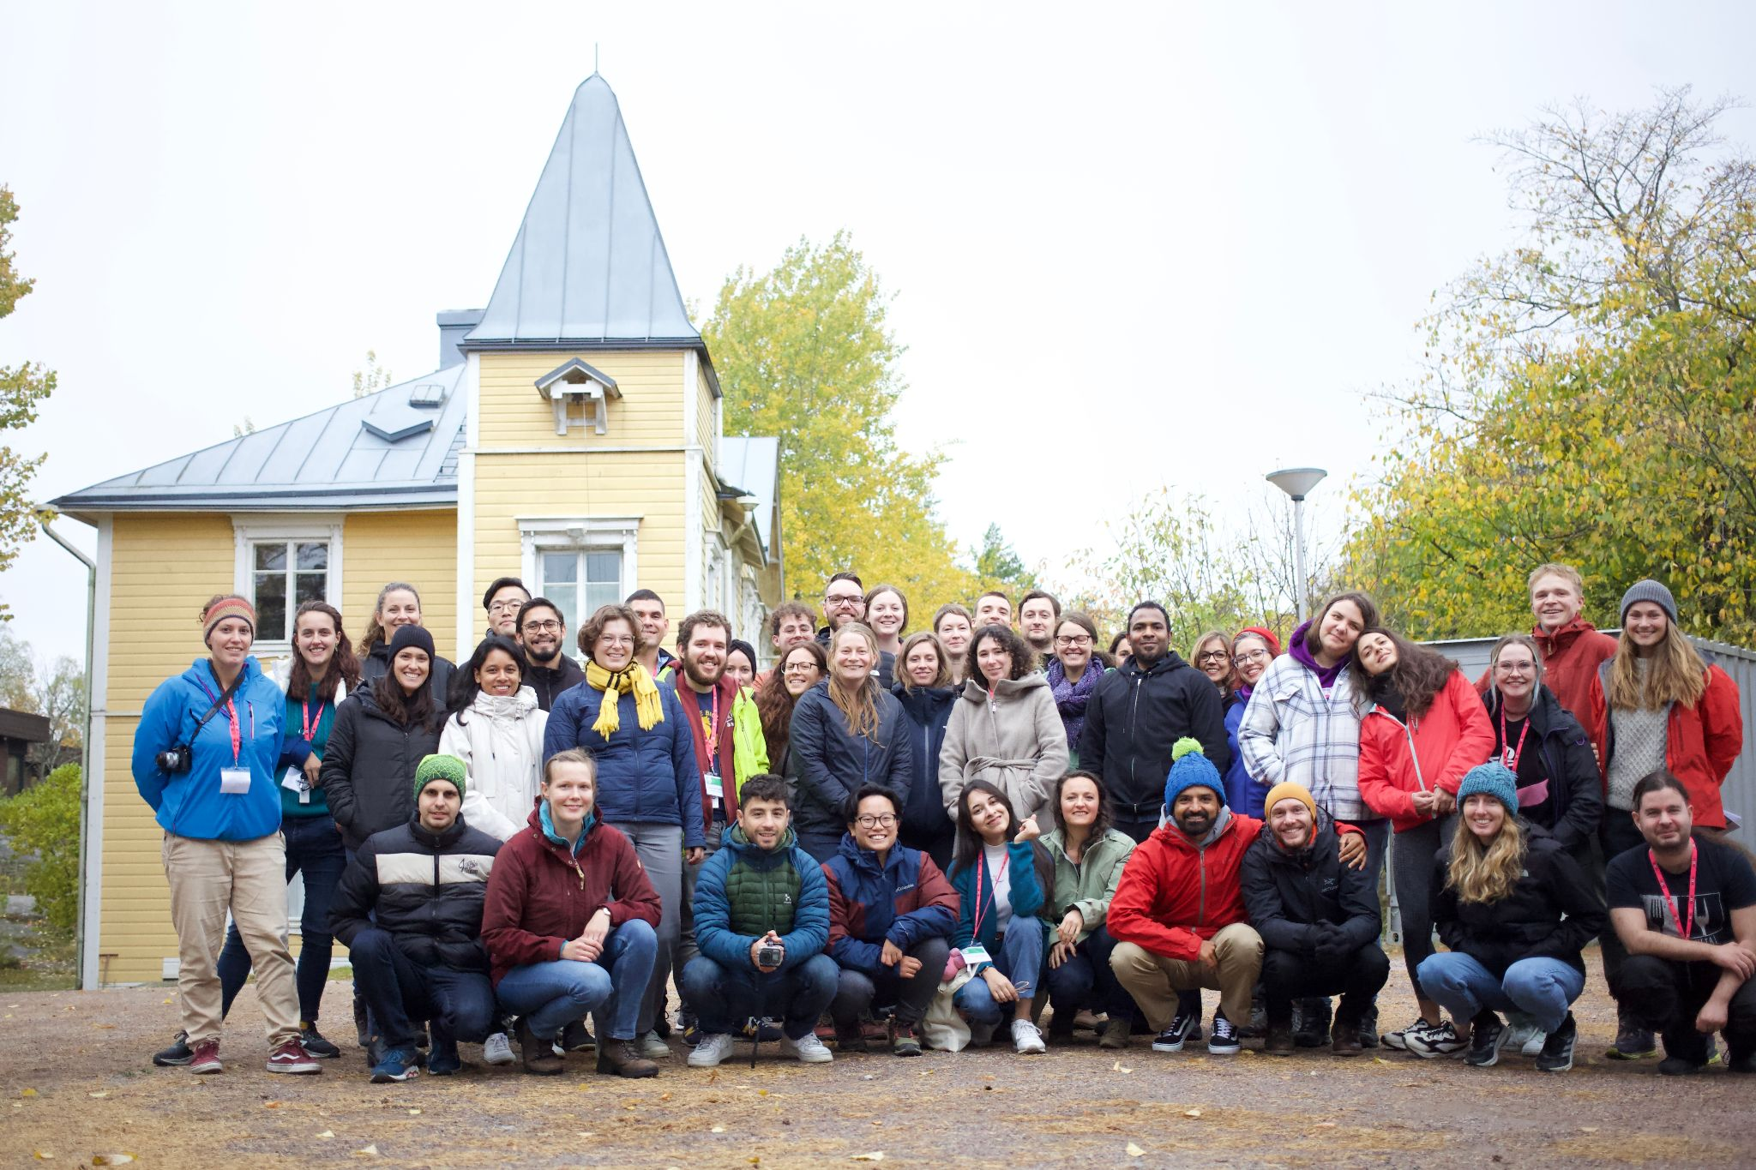

*All the participants gathered in front of the old main building of the station*

The days at the symposium were centered around sessions of oral presentations, interspersed with (frequent) meals and snack- and coffee breaks. Evenings and afternoons included poster-presentations, social indoor- and outdoor activities and sauna by the sea. The social aspect was central to this symposium. Thanks to the fairly remote location, participants spent their time socializing in close quarters, which made a big difference in lowering the threshold to spontaneous discussions and making friends with new people. With various organized activities (team games, nature trail, sauna, morning swims, and an open electronics workshop run by Sergey Morozov) we also got people to interact in diverse ways, helping to make new connections that are hopefully long lasting.

The scientific content of the symposium was at an impressively high level. All the presenters had put in a noticeable effort to make engaging and interesting presentations on their research, and there were usually more questions than there was time to answer them from the audience (hence discussions continued late into the evenings). The presentations spanned a broad range of topics, covering behavior, development, reproduction, physiology, ecotoxicology, neurology, anthropogenic stressors, evolution, genetics, and much more. A similarly broad range of study systems and organisms were also represented, including birds, insects, mammals, fish, daphnids, tardigrades, and amphibians. One of the highlights was hearing about the history of and research conducted at the station by Ilse Klockars and Camilla Gustafsson.

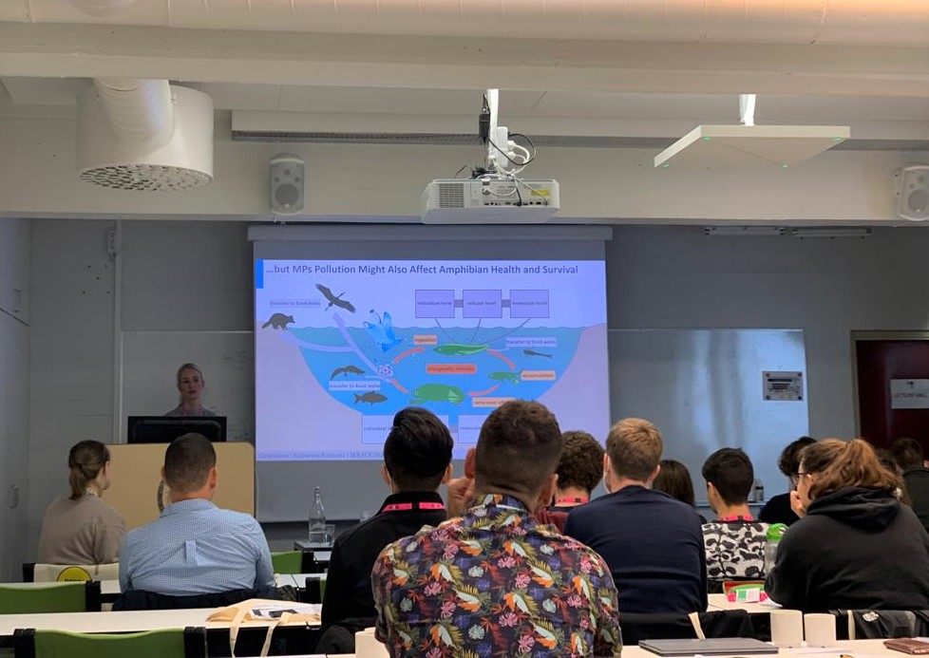

*Katharina Ruthzats presenting on the effects and carryover effects of microplastics in African clawed frogs*

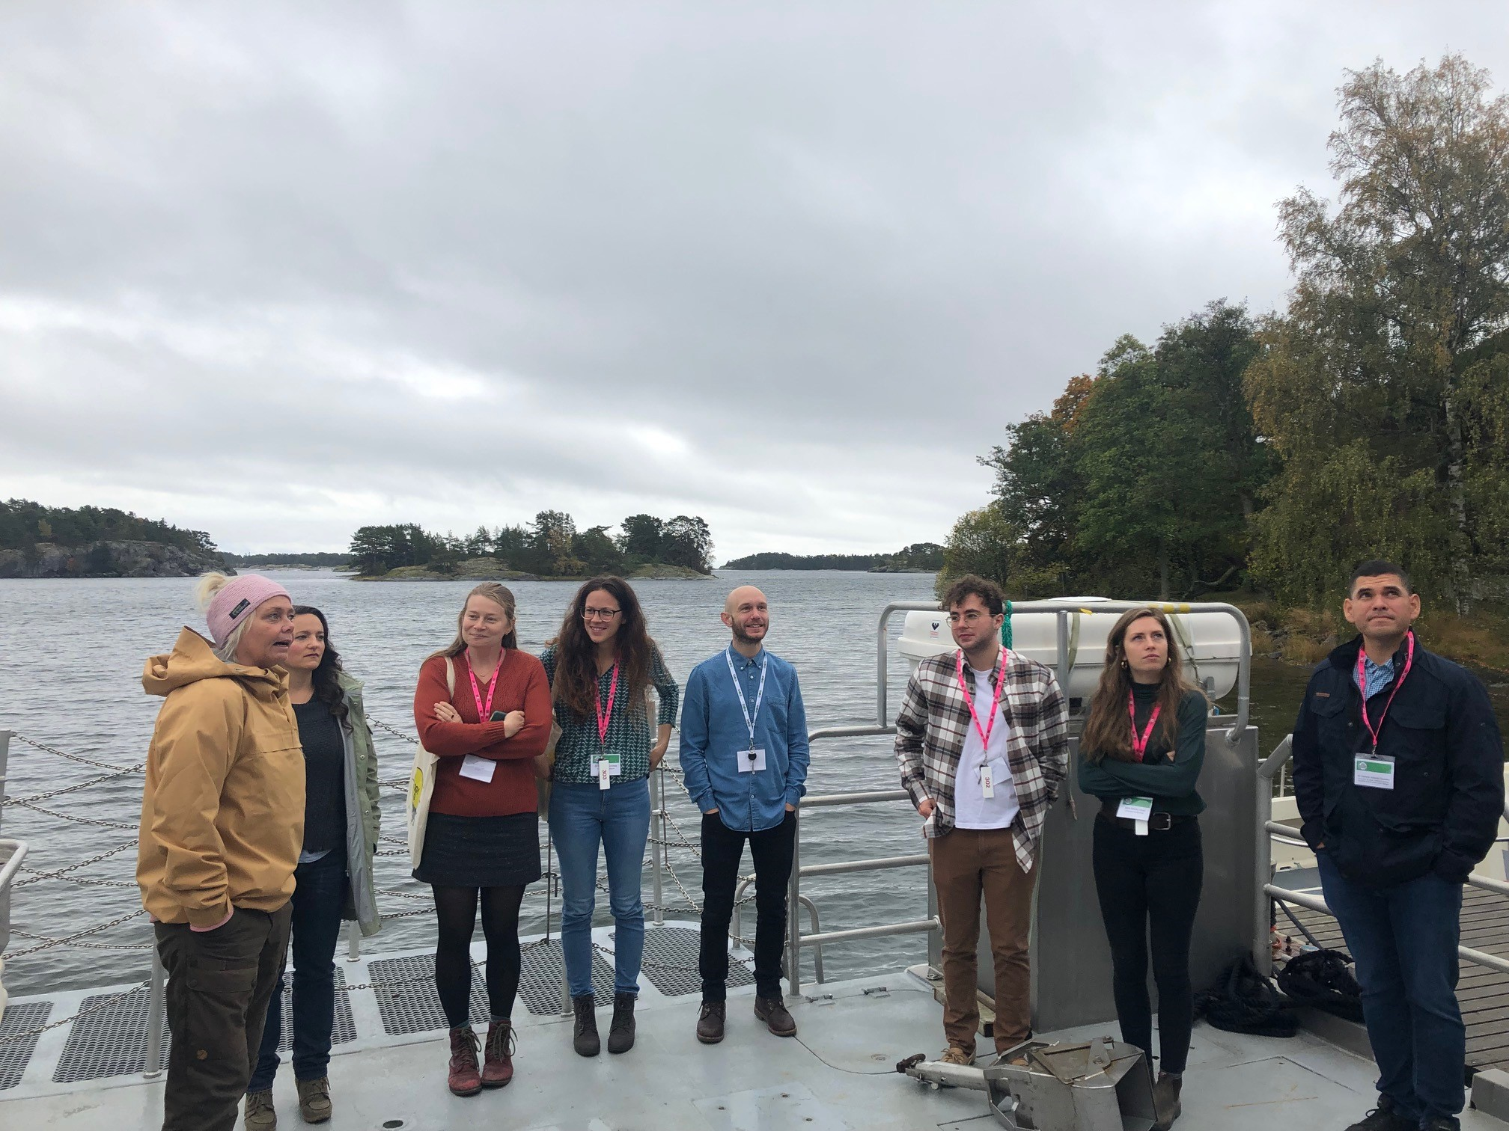

*Ilse Klockars (left) introducing attendees (from left to right: Ashlee Mikkelsen, Amelia Munson, Daphne Cortese, Tommy Norin, Vincent Mélançon, Marie Levet, and Antonio Cordero) to the state-of-the-art research vessel Augusta.*

Attendees were often engaged in conversation with our four keynote speakers, and thoroughly enjoyed their presentations. Prof. Shaun Killen kicked off the symposium with a presentation that pivoted from social behavior in fish to social behavior in academics, talking about the benefits and challenges of collaboration in biological science, and opened a discussion by talking about his personal experiences with impostor syndrome, which many of us could no doubt relate to. Dr. Julia Nowack presented on the evolution of heterothermy in mammals, taking a global approach to look at the patterns of phenotypic plasticity in torpor in different climates. Dr. Rose Thorogood talked about how behavior and the social environment lead to adaptive variation using a field-based experimental study on cuckoos and their reed warbler hosts. Finally, Dr. Valentina Di Santo presented on the diversity of locomotory behavior in fish and the many surprising aspects of the energetics of fish locomotion in groups or in solitary swimmers.

Overall, we (the organizers) are left with an incredibly positive feeling after this symposium. After a long time in isolation from the larger scientific community, meeting this wonderful group of energetic and aspiring researchers has been a major boon for motivation, inspiration, and collaboration. The extremely positive feedback from the participants indicated that they felt the same, and we are immensely grateful for the SEB and the University of Helsinki for hosting the symposium! Hopefully we get to see many more ECR meetings like this organized by the SEB in the future.

Organizers:

Jenni Prokkola, Natural Resources Institute Finland (LUKE)

Eirik Åsheim, University of Helsinki

Anna Andreassen, Technical University of Norway

Jacinta Kong, Trinity College Dublin

Tommy Norin, Technical University of Denmark